**Frontend Development with React.js Project Documentation format**



# Introduction

• **Project Title**: Fit flex • **Team leader**:

MADHAN KUMAR V

([vetrivelmuruga123456@gmail.com](mailto:vetrivelmuruga123456@gmail.com))

**[TEAM MEMBERS]**

LOKESH KUMAR S

([lokesh200506@gmail.com](mailto:lokesh200506@gmail.com))

KUMARESAN M

([kumaresan20042004@gmail.com](mailto:kumaresan20042004@gmail.com))

KUMARESAN S

([s.kumaresan0211@gmai.com](mailto:s.kumaresan0211@gmai.com))

LOGESH.K

([klllogesh7904@gmail.com](mailto:klllogesh7904@gmail.com))



# Project Overview

• **Purpose**:

The Fitness Application is designed to help users monitor their fitness activities, track progress, and set fitness goals. The application provides a user-friendly interface for logging workouts, tracking calories, and visualizing progress over time. • **Features**:

o User authentication (login/signup) o Dashboard for tracking daily activities o Workout logging and history o Calorie tracker o Progress charts and analytics o Responsive design for mobile and desktop



# Architecture

* **Component Structure**:
  + **App Component**: The root component that manages routing and global state. o **Dashboard Component**: Displays user’s daily fitness metrics and progress. o **WorkoutLog Component**: Allows users to log and view their workout history.
  + **Auth Component**: Handles user authentication (login/signup). • **State Management**:
  + **Redux**: Used for global state management to handle user authentication, workout data, and calorie tracking.
  + **Local State**: Managed within individual components using React’s useState and useEffect hooks.
* **Routing**:
  + **React Router**: Used for navigation between different pages (e.g., Dashboard, Workout Log, Calorie Tracker).



# Setup Instructions

• **Prerequisites**:

o Node.js (v16 or higher) o npm (v8 or higher) o Git (for cloning the repository) • **Installation**:

1. Clone the repository: git clone https://github.com/your-repo/fitness-tracker.git
2. Navigate to the client directory: cd fitness-tracker/client
3. Install dependencies: npm install
4. Configure environment variables: Create a .env file in the client directory and add the necessary variables (e.g., API keys).
5. Start the development server: npm start



# Folder Structure

• **Client**:

* **src/components**: Contains all React components (e.g., Dashboard, WorkoutLog, CalorieTracker).
* **src/pages**: Contains page components that are rendered based on the route. o **src/assets**: Stores static assets like images, icons, and styles. o **src/redux**: Contains Redux store, actions, and reducers.
* **src/utils**: Utility functions and custom hooks. • **Utilities**:
* **useFetch**: Custom hook for making API requests. o **formatDate**: Utility function for formatting dates.
* **calculateCalories**: Helper function for calculating calorie intake and expenditure.



# Running the Application

• **Frontend**:

o Navigate to the client directory: cd client o Start the development server: npm start o The application will be available at http://localhost:3000



# Component Documentation

* **Key Components**:
  + **Dashboard Component**: Displays user’s daily fitness metrics (e.g., steps taken, calories burned). Receives props like userData and progressData.
  + **WorkoutLog Component**: Allows users to log workouts and view their history. Receives props like workouts and onLogWorkout.
  + **CalorieTracker Component**: Tracks daily calorie intake and expenditure. Receives props like calorieData and onUpdateCalories.
  + **ProgressChart Component**: Visualizes user progress using charts. Receives props like progressData and chartType.
* **Reusable Components**:
  + **Button**: A reusable button component with customizable styles and onClick handlers.
  + **InputField**: A reusable input field component for forms, with validation support. o **Modal**: A reusable modal component for displaying pop-ups or alerts.



# State Management

• **Global State**:

* **Redux Store**: Manages global state for user authentication, workout data, and calorie tracking. Actions like LOGIN_USER, ADD_WORKOUT, and UPDATE_CALORIES are dispatched to update the state.
* **State Flow**: The state flows from the Redux store to components via useSelector and is updated using useDispatch. • **Local State**:
* Managed within components using React’s useState and useEffect hooks. For example, the WorkoutLog component uses local state to manage the form inputs for logging workouts.



# User Interface

* **Screenshots**:
* **Screenshots are below** :

* **Dashboard**:

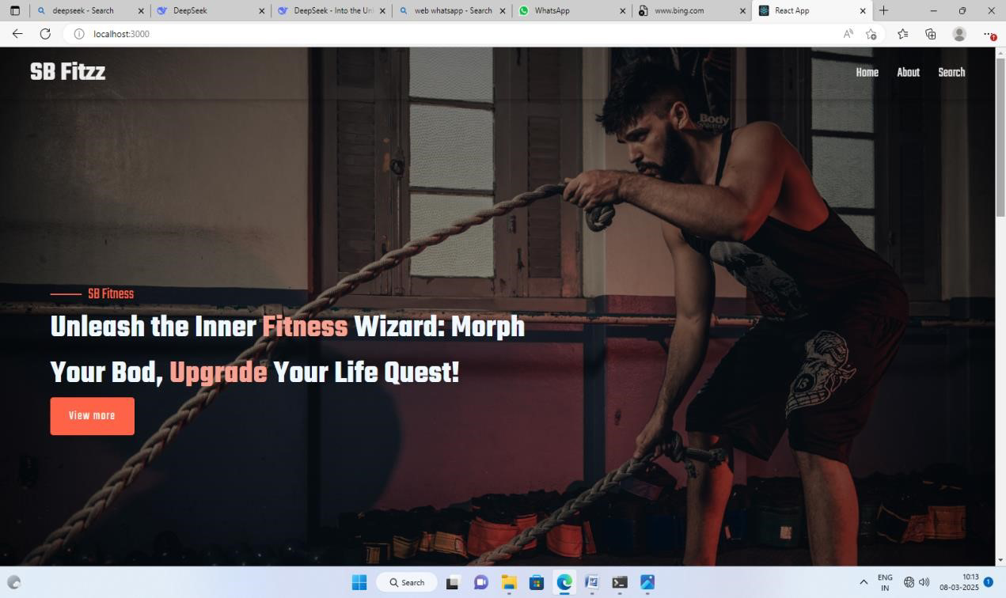 o **Search Page**:

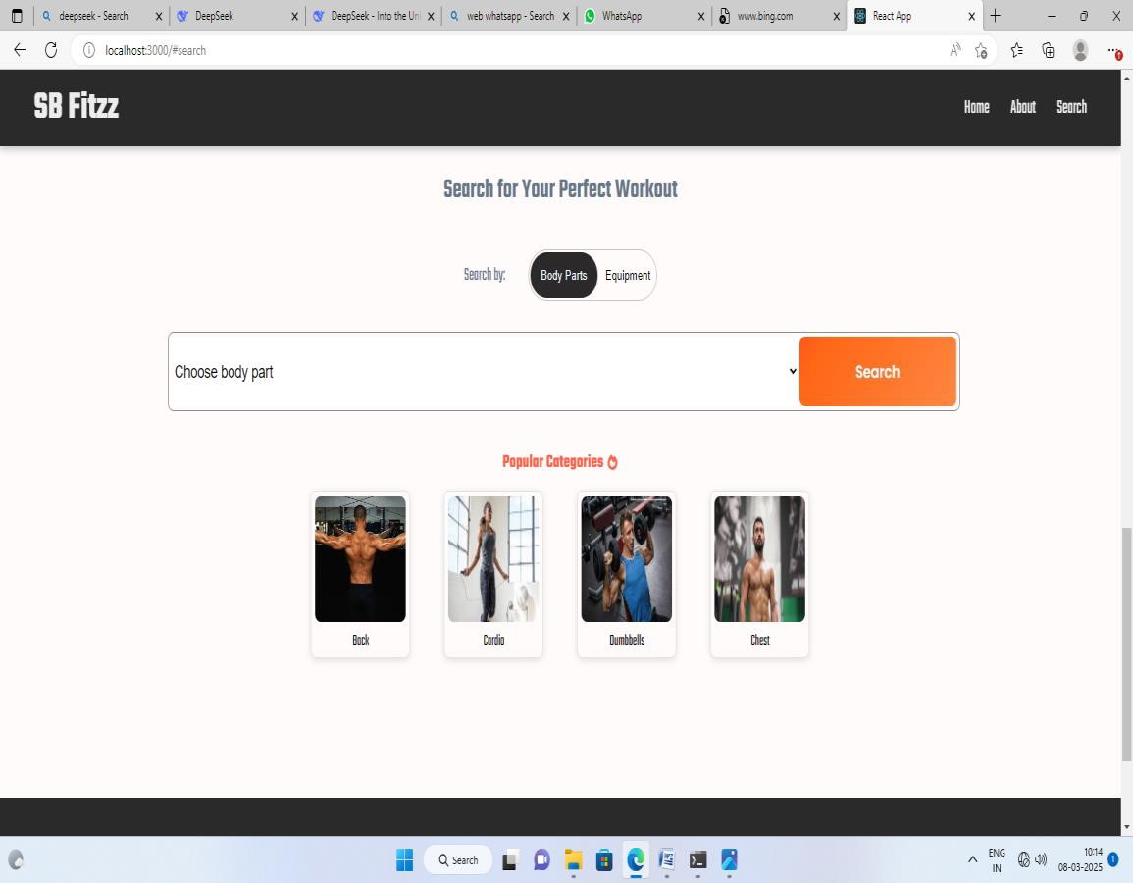

* **Work**

**Log**:





# Styling

• **CSS Frameworks/Libraries**:

* **Styled-Components**: Used for component-level styling.
* **Bootstrap**: Used for responsive grid layouts and pre-built components. • **Theming**:
* A custom theme is implemented using Styled-Components, with support for light and dark modes.



# Testing

• **Testing Strategy**:

* **Unit Testing**: Jest and React Testing Library are used for unit testing individual components.
* **Integration Testing**: Ensures that components work together as expected. o **End-to-End Testing**: Cypress is used for end-to-end testing of user flows (e.g., logging in, logging workouts). • **Code Coverage**:
* Code coverage is monitored using Jest’s built-in coverage tool. The current coverage is 85%.



# Screenshots or Demo

* **Demo Link**:  [React App](http://localhost:3000/)
* **Screenshots**: See section 9 for UI screenshots.



# Known Issues

* **Issue 1**: The calorie tracker sometimes fails to update in real-time when the user logs a meal.
* **Issue 2**: The progress chart may not render correctly on older browsers.
* **Issue 3**: The mobile navigation menu occasionally overlaps with content on smaller screens.



# Future Enhancements

• **New Features**: o Integration with wearable devices (e.g., Fitbit, Apple Watch).

* Social features to share progress with friends.
* Gamification (e.g., badges, rewards for achieving fitness goals). • **UI/UX Improvements**:
* Add animations for a more engaging user experience.
* Improve the mobile navigation menu for better usability. • **Performance Optimization**:
* Optimize the rendering of charts for better performance on low-end devices. o Implement lazy loading for components to reduce initial load time.



This documentation provides a comprehensive overview of the Fitness Tracker Application, including its architecture, setup instructions, and future enhancements.

New chat